The September 19, 2017 M_{w} 7.1 Puebla-Mexico City Earthquake: Observed Rockfall and Landslide Activity
Jack Montgomery, Gabriel Candia, Anne Lemnitzer, Alejandro Martinez
ABSTRACT
This note documents key observations of slope instability and rockfall activity made by the UNAM-GEER reconnaissance team after the M_{w} 7.1 Puebla-Mexico City earthquake of September 19, 2017. The investigated sites were located in Mexico City and the states of Morelos, Puebla and Mexico. Sites were studied using a combination of ground surveys, UAV imagery, and terrestrial LiDAR imaging. The field reconnaissance efforts were supplemented by analysis of pre- and post-event satellite images to define the boundary of the region affected by earthquake-induced landslides. Most slope failures occurred in remote areas or areas that had a prior history of instability. Overall, the consequences of slope instabilities caused by the 2017 Puebla-Mexico City earthquake were relatively minor compared with the reported structural damage. More than 360 deaths were attributed to this earthquake of which one death was attributed to landslide activities. The size of the area affected by landslides and the intensity of shaking in these areas was consistent with relationships developed in previous studies. The lack of major effects from earthquake-induced landslides is consistent with previous earthquakes in southern Mexico and stands in sharp contrast to many parts of Central America where earthquake-induced landslides pose a significant hazard.

Keywords: Earthquakes, Mexico, landslides, rockfalls; field reconnaissance
1. Introduction
Earthquake-induced landslides are common natural hazards following strong ground motions and have led to significant damage and casualties in recent earthquakes. In some Central American countries, earthquake-induced landslides have been one of the most significant sources of casualties (e.g., more than 1000 victims lost their lives during the 2001 El Salvador earthquake [1]). In Mexico, casualties from earthquake-induced landslides are often significantly smaller. Even though more than 3500 deaths in Mexico have been attributed to landslide-related disasters between 1935 and 2006 [2], most of these slides have been associated with intense precipitation events such as tropical storms or hurricanes. Bommer and Rodrı́guez [1] suggest that based on the geological and meteorological conditions in Central America and southern Mexico, earthquake-induced landslides are highly non-uniform across the region, but they are more frequent in countries like Costa Rica, El Salvador, Guatemala, and Panama. Reasons for the increased frequency in these countries relative to southern Mexico includes higher mean annual rainfall and geologic units that are more susceptible to landslides, including lateritic soils and volcanic ash deposits [1]. In addition, the exposure of the population and infrastructure to potentially unstable slopes appears to be greater in Central America, where approximately half of the population is concentrated around volcanoes along the Pacific coast [1].
The September 19, 2017 Puebla-Mexico City was an intraslab subduction zone earthquake with a moment magnitude (M_{w}) of 7.1. The earthquake occurred at a depth of 57 km and the epicenter was located approximately 60 km southwest of Puebla, Mexico and 120 km southeast of Mexico City, Mexico. Strong ground motions, those that exceeded an intensity level VII according to the Modified Mercalli Intensity (MMI), were felt in both Mexico City and Puebla [3]. This event led to at least 369 confirmed deaths, approximately 60% of them in Mexico City and 20% in the state of Morelos, and severely damaged infrastructure such as buildings, roads, bridges, and lifelines [4]. The affected region is primarily located in the Trans-Mexican volcanic belt, which is characterized, by volcanic mountain ranges and humid mountain valleys [5]. The geology in this region consists primarily of volcanic soils and rocks with alluvial and lacustrine deposits occurring in the valleys [5, 6]. Sedimentary rocks (limestone, sandstone, siltstone and shale) are also found in the states of Morelos and Puebla [6].
The Puebla-Mexico City earthquake led to co-seismic landslides in the states of Mexico, Puebla and Morelos. The GEER-UNAM reconnaissance team visited eight areas where rockfalls and landslides were observed to document deformations and impacts using a combination of visual observations, unmanned aerial vehicle (UAV) photography and LiDAR scans. The impacts of the investigated failures on infrastructure varied significantly and included damage to buildings, roadways and retaining structures. Only one casualty associated with landslide or rockfall activities was reported in post-earthquake news stories [7]. The reconnaissance team also documented damage at seven quarries in the state of Morelos, although there were no reported injuries at these sites. This paper summarizes the observations of rockfalls and landslides documented by the reconnaissance team and includes a brief summary of geologic and antecedent rainfall conditions at the landslide sites. A discussion of the impacts of the landslides along with a comparison of the observations with those from other recent earthquakes is included.
2. Previous Earthquake-Induced Landslides in Southern Mexico
Earthquake induced landslides have been reported in past Mexican earthquakes going back to 1912 [1]. In all of these earthquakes, only limited landslide activity has been documented in southern Mexico and only a small number of casualties have been attributed to earthquake-induced landslides [1]. The causalities that have been attributed to landslides have primarily occurred in more remote mountain regions. Areas affected by landslides in several of these earthquakes are shown in Figure 1 (adapted from Bommer and Rodrı́guez [1]).
Figure 1. Map showing the locations of historical instabilities in southern Mexico [1] along with landslides observed from the September 19 (M_{w} 7.1) earthquake.

3. Survey Approach and Methods
Site visits were performed at eight locations were slope instabilities were observed within the metropolitan area of Mexico City and the states of Mexico and Morelos (Figure 2, Table 1). UAV photography was used at several sites to provide insights into slope failure formations (Figure 3a) and to map ground cracking behind failure scarps that were not easily accessible to the reconnaissance teams on the ground. LiDAR scans were taken at select locations including the failure of a river bank along the Yautepec River in the state of Morelos (Figure 3b).
Figure 2. Map showing the locations of landslides documented after the Puebla-Mexico City earthquake along with contours of Modified Mercalli Intensity [3].

Table 1. Observations of slope instabilities and rock falls from the 2017 Puebla-Mexico City earthquake
Name of City/Region | Lat. (°) | Long. (°) | Type of Instability | Date Visited (2017)
Xochimilco | 19.2467 | -99.0872 | Landslide/Subsidence | 9/25, 9/26, 10/2
Tlayacapan | 18.9486 | -98.9837 | Rockfall | 9/27, 10/2
Totolapan | 18.9816 | -98.9246 | Slope failure in old quarry | 9/27, 10/2, 10/3
Atlatlahucan | 18.9378 | -98.8784 | Series of landslides | 9/27, 10/3
Rio Yautepec | 18.7307 | -99.1194 | Slope failure near bridge | 10/3, 10/4
Río Apatlaco | 18.6123 | -99.1817 | Failure of river bank | 9/27
Lake Tequesquitengo | 18.6313 | -99.2538 | Movement along lake shore | 9/27
Tejalpa-Zacatepec Highway | 18.7146 | -99.1835 | Embankment failure | 9/27

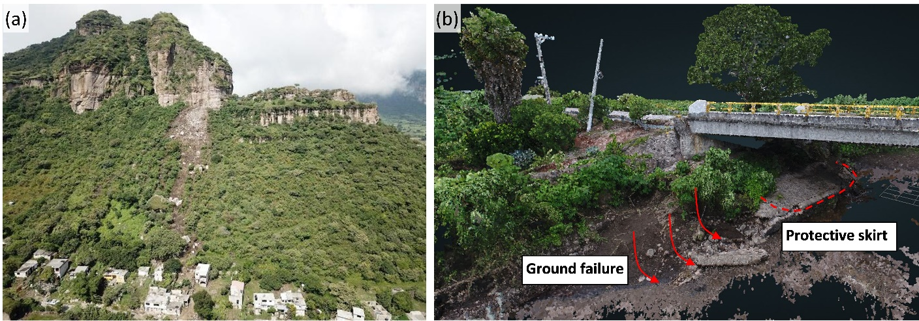
Figure 3. (a) (a) Aerial view of a rockfall near Tlayacapan showing the hill crest, the depleted vegetation left by boulders, and houses beneath the slope (18.9486°, -98.9837°); (b) Point cloud data created from a LiDAR scan showing the ground failure next to a bridge across the Río Yautepec (18.7306°, -99.1194°).

Following the initial reconnaissance effort, the team used satellite imagery available from before and after the event to attempt to delineate the boundaries of the area affected by landslides (Figure 1). This review was done by comparing monthly mosaic images provided by Planet Labs [8] from July and August 2017 (pre-event) and October 2017 (post-event). The images were collected by the PlanetScope satellite and have a resolution of 3-meters. At this resolution it is not likely that landslides with an area smaller than 225 m² could be observed [e.g., 9, 10]. Possible landslide sites were highlighted using the Planet Explorer tool [8], which detects changes in the relative luminance between the two images (pre- and post-event) and then confirmed using post-event imagery from Planet [8] or Google Earth [11]. This process led to the identification of six additional areas where landslides occurred (Figure 2).

4. Observations
The reconnaissance team visited eight locations where slope instabilities were observed (Table 1) during September and October of 2017. One landslide was located in the southern part of Mexico City while the other areas were located in the state of Morelos (Figure 2). Similar to previous earthquakes in southern Mexico [1], the reported impacts of earthquake-induced landslides from the 2017 Puebla-Mexico City earthquake were relatively minor. The reconnaissance team documented a total of 14 areas where landslides were observed. Some of these were a single landslide (e.g., Tlayacapan Rockfall, Figure 3a), while others were multiple landslides that occurred over a larger area (e.g., Atlatlahucan was comprised of six landslides occurring along a 2 km ridge). All of the landslides were observed in areas to the northwest of the epicenter, which is also consistent with reports of significant structural damage that were concentrated in the state of Morelos and Mexico and in Mexico City. Details on the observations at each of the landslide sites (e.g., additional photos, maps, eyewitness accounts, and displacement measurements) are described in the GEER report [4].

4.1 Comparison with Patterns from Previous Earthquakes
The landslide locations documented by the reconnaissance team were compared with the Modified Mercalli Intensities estimated by the USGS [3] for this event (Figure 2). All of the landslides occurred in areas where the intensity was at least V, which is consistent with the boundaries of observed landslides identified by Keefer [12] and Rodrı́guez et al. [13] based on their global datasets. The maximum epicentral distance was approximately 100 km which is also consistent with the relationships proposed by Keefer [12] and Rodrı́guez et al. [13].
The size of the area affected by landslides from this earthquake was defined by fitting a boundary convex hull to the observed sites and then smoothing that polygon using a Bezier interpolation (Figure 1). The resulting boundary polygon has an area of 6440 km². This is less than half of the area suggested by the upper bound relationship proposed by Rodrı́guez et al. [13] based on a global database, but is well within the scatter of data observed by Bommer and Rodrı́guez [1] for similar magnitude earthquakes in Central America and southern Mexico.

4.2 Geology
The geologic units in which landslides occurred were identified by comparing the landslide locations (Figure 2) with a geologic map of central and southern Mexico [6]. The majority of the landslides documented in this study occurred in units containing primarily volcanic soils and rock (tuff, basalt, andesite, and dacite) and lahar deposits (deposits from volcanic debris flows). Earthquake-induced landslides in volcanic soils are also common in Guatemala, El Salvador, Nicaragua and Costa Rica [1] and weak lenses in volcanic deposits have been cited as a possible factor in the large number of landslides observed in the 2018 Hokkaido Earthquake [14]. The only failures observed outside of these volcanic deposits occurred along river banks in recent alluvial deposits (e.g., Río Yautepec, Figure 3b).

4.3 Rainfall Conditions
The effects of antecedent rainfall on earthquake-induced landslides are well-documented, where both the medium-term (6 - 12 months) and short-term (1 month) antecedent rainfalls can have important influence in determining the susceptibility to instability and the extent of the affected area [1]. A review of rainfall in the twelve months leading up to the earthquake was performed for each of the landslide areas (Figure 2) using data collected at the closest weather station [15]. The highest rainfall totals were observed in the state of Morelos where the majority of landslides were observed. The rainfall in Morelos during the three months prior to the earthquake (July, August, and September of 2017) was between 238 and 289 mm, which is from 120% to 140% of the monthly historic average for those months [16]. The rainfall between January and May of 2017 was between 2 and 52 mm, which is approximately 50% of the historic average. The lowest rainfalls in the months prior to the earthquake were recorded at sites located in the states of Puebla and Mexico where the fewest landslides were observed, despite similar shaking intensities to Morelos (Figure 2). The uptick in rainfall in Morelos in the months prior to the earthquake may be part of the reason why the majority of landslides were observed in this state.

4.4 Landslide Impacts
The impact of the observed landslides on the affected communities varied significantly. The slide in the hills of Xochimilco (Figure 4) ruptured water lines and blocked local roads leading to traffic jams and increased travel times. This landslide also caused damage to roadways (Figure 5a), retaining walls (Figures 5b and 5c), sidewalks and buildings. This area has a history of subsidence and slope instability, including during the 1985 Michoacan Earthquake [17]. Landslides in more rural areas affected smaller populations, but also damaged buildings and roadways. The damage to the Yautepec bridge in Morelos led to a 5 km detour for the residents of the town of Estacas. The landslides in Totolapan and Tlayacapan did not cause major damage to homes, but left behind unstable slopes (Figure 6). Slope failures were observed in several quarries, including one fatal incident in the State of Mexico where one worker was killed when the earthquake triggered a rockfall [7]. Other quarry instabilities with only limited damage were observed in the cities of Totolapan (Figure 6) and Atlatlahucan in Morelos.
Figure 4. Aerial view of Xochimilco slopes, showing the trace of surface cracks, the locations of pumping station and previously repaired void. Letters indicate sites shown in Figure 5. (19.2471°, -99.0882°).

Figure 5. (a) Large residual displacements in asphalt pavement (site A, 19.2467°, -99.0870°); (b) Retaining wall supported with wooden cross braces in Vieja Xochimilco-Tulyehualco (site B, 19.2470°, -99.0897°); (c) failed section of retaining wall in Vieja Xochimilco-Tulyehualco (site C, 19.2470°, -99.0895°).

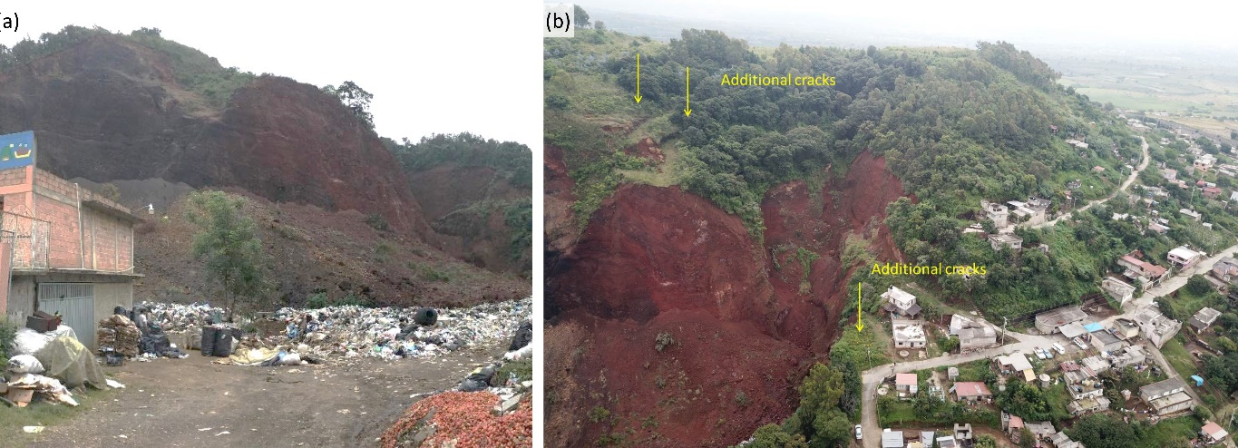
Figure 6. (a) Landslide in former Tezontle quarry and current landfill (18.9816°, -98.9246°); (b) cracks near homes above the former Tezontle quarry after the earthquake (18.9816°, -98.9246°).

6. Summary
The UNAM-GEER reconnaissance team investigated eight instances of slope instability following the 2017 Puebla-Mexico City earthquake. The investigated failures occurred in Mexico City and the states of Morelos and Mexico. Many failures occurred in areas that had a prior history of instability. The impacts of the failures on the local communities varied significantly between the sites with some failures causing little to no damage or disruption (e.g., the Atlatlahucan quarries) and others leading to damaged buildings and transportation infrastructure (e.g., Xochimilco and Río Yautepec). The reconnaissance team documented the case histories using a combination of ground surveys, UAV imagery and terrestrial LiDAR imaging. Additional landslide areas were identified using pre- and post-event satellites images.
The documented locations of slope instability were identified through field observations by the reconnaissance team, discussions with local residents, and post-reconnaissance mapping using satellite images. It is likely that more instances of earthquake-induced instabilities occurred which were not documented by the team. While a review of pre- and post-event satellite images was performed for this study, the resolution of the imagery only allowed for detection of landslides with areas greater than approximately 225 m² as discussed in Section 3. A more detailed remote sensing based study [e.g., 14] would allow for a detailed statistical analysis of the patterns of co-seismic landslides triggered by this event.
Overall, the slope stability issues caused by the 2017 Puebla-Mexico City earthquake were relatively minor compared with the reported structural damage [4]. The size of the area affected by earthquake-induced landslides and the threshold MMI for landslide observations from this event was consistent with observations from previous earthquakes [1, 12, 13]. The lack of major impacts is consistent with observations from previous earthquakes in southern Mexico [1]. This stands in contrast to other regions, such as Central America, where earthquake-induced landslides are a significant source of both damage and casualties [1].

Acknowledgements
The work of the GEER Association is based in part on work supported by the National Science Foundation through the Geotechnical Engineering Program under Grant No. CMMI 1266418. We acknowledge and thank UNAM for the resources, space and personnel provided to the GEER team during this reconnaissance effort. The authors of this article also acknowledge the hard work of the entire UNAM-GEER reconnaissance team, which greatly contributed to documentation of all of the case histories discussed here. Additional funding for the site reconnaissance was provided to the second author by Universidad del Desarrollo, the National Research Center for Integrated Natural Disaster Management CONICYT/FONDAP/15110017, and SIBER-RISK Fondecyt Grant 1170836. Any opinions, findings, conclusions or recommendations expressed in this article are those of the authors and do not necessarily reflect the views of these organizations.

References
[1] Bommer, J. J., & Rodrı́guez, C. E. (2002). Earthquake-induced landslides in Central America. Engineering Geology, 63(3-4), 189-220.
[2] Alcántara-Ayala, I. (2008). On the historical account of disastrous landslides in Mexico: the challenge of risk management and disaster prevention. Advances in Geosciences, 14, 159-164.
[3] United States Geological Survey (USGS) (2017). Event page for M 7.1 - 1km E of Ayutla, Mexico, https://earthquake.usgs.gov/earthquakes/eventpage/us2000ar20/executive [Accessed April 18, 2019].
[4] Mayoral, J. M., Hutchinson, T. C., Franke, K. W. et al. (2018). Geotechnical Engineering Reconnaissance of the 19 September 2017 Mw 7.1 Puebla-Mexico City Earthquake Version 2. Geotechnical Extreme Events Reconnaissance Association, DOI: 10.18118/G6JD46.
[5] Alcocer, J., & Bernal-Brooks, F. W. (2010). Limnology in Mexico. Hydrobiologia, 644(1), 1-54.
[6] Servicio Geológico Mexicano (2019). GeoInfoMex, El Banco de Datos del SGM. https://www.sgm.gob.mx/GeoInfoMexGobMx/ (in Spanish) [Accessed July 30, 2019].
[7] Associated Press (AP) (2017). The Latest: Death toll rises to 226 from Mexico earthquake, https://apnews.com/f6e1ffab3ccc4057a8ba47765c8c9632 [Accessed: July 3, 2018].
[8] Planet Team (2017). Planet Application Program Interface: In Space for Life on Earth. San Francisco, CA. https://api.planet.com [Accessed April 17, 2019].
[9] Ma, H. R., Cheng, X., Chen, L., Zhang, H., & Xiong, H. (2016). Automatic identification of shallow landslides based on Worldview2 remote sensing images. Journal of Applied Remote Sensing, 10(1), https://doi.org/10.1117/1.JRS.10.016008.
[10] Westen, C. J. (2000). Introduction to GISSIZ (Geographic Information Systems in Slope Instability Zonation). International Institute for Geo-Information Science and Earth Observation (ITC), Enschede, The Netherlands
[11] Google Earth (2019). Google Earth Pro V. 7.3.2. Google, LLC. Mountain View, CA.
[12] Keefer, D. K. (1984). Landslides caused by earthquakes. Geological Society of America Bulletin, 95(4), 406-421.
[13] Rodrı́guez, C. E., Bommer, J. J., & Chandler, R. J. (1999). Earthquake-induced landslides: 1980–1997. Soil Dynamics and Earthquake Engineering, 18(5), 325-346.
[14] Wang, F., Fan, X., Yunus, A. P., Subramanian, S. S., Alonso-Rodriguez, A., Dai, L., Xu, Q., & Huang, R. Coseismic landslides triggered by the 2018 Hokkaido, Japan (M_{w} 6.6), earthquake: spatial distribution, controlling factors, and possible failure mechanism. Landslides, 16, 1551-1556.
[15] Servicio Meteorológico Nacional (SMN) (2019). Precipitación. SMN. https://smn.cna.gob .mx/es/climatologia/pronostico-climatico/precipitacion-form (in Spanish) [Accessed: May 5, 2019].
[16] Climate Data (2019). Clima: México. Climate Data. https://es.climate-data.org/america-del-norte/mexico-179/ (in Spanish) [Accessed: May 5, 2019].
[17] Ayala, A. G., & O'Rourke, M. J. (1989). Effects of the 1985 Michoacan earthquake on water systems and other buried lifelines in Mexico. Technical Report NCEER-89-0009, National Center for Earthquake Engineering Research, Buffalo, NY, 140 pp.

Assistant Professor, Department of Civil Engineering, Auburn University, Auburn, AL, USA (Corresponding author: jmontgomery@auburn.edu)
Associate Professor, Facultad de Ingeniería Civil Universidad del Desarrollo, Chile. National Research Center for Integrated Natural Disaster Management (CIGIDEN) CONICYT/FONDAP/15110017, Chile
Associate Professor, University of California, Irvine, CA, USA
Assistant Professor, University of California Davis, Davis, CA, USA

