Internal and External Factors Explaining Chilean Economic Activity

Guillermo I. Acuña
Centro de Estudios en Economía y Negocios
Facultad de Economía y Negocios
Universidad del Desarrollo, Chile
Email: guacunas@udd.cl

Working Paper – July 2017

Abstract
The objective of this paper is to find which factors were the most important to explain the contraction of the economic activity in Chile during the last three years. The results show that: (1) the fall in the rate of growth of the economy is explained by external factors, like the end of the mining boom; (2) the subsequent and persistently low growth rates are explained by a combination of internal and external factors, where the internal factors were the most important.

Introduction

In the present paper, I study the effect of the internal and external factors affecting economic activity in Chile during the period 2007-2016. In particular, I want to identify which factors are the most important to explain the contraction in economic activity during the last three years.

I use two methodological approaches to analyse the data. The first one is inspired on the work of Elías Albagli and Emiliano Luttini: Confianza, Incertidumbre e Inversión en Chile: Evidencia Macro y Micro de la Encuesta IMCE, since I use the same Structural VAR methodology (SVAR) to analyse the dynamics of the variables of interest.

I am interested in studying the effect of internal and external factors on overall economic activity, using variables taken from the IPECO survey as measures of the economic agents’ confidence and uncertainty (internal factors). I think this data is the best suited to measure confidence and uncertainty, since the survey measures the perceptions of Chileans in general, without distinguish by the occupation of the respondents, unlike the producers’ surveys, which are focused in business managers from a small group of economic sectors.

Besides, I use a second methodological approach, that also uses a VAR model, but is focused in the study of the dynamics of the coefficients of the model, through rolling windows estimates. In this way, I want to find which variables have the greater effect on the rate of growth of the economic activity in each consecutive sub-sample.

The results show that the decrease in the rate of growth of the economy is explained by external factors, probably because of the end of the mining boom and the low price of cooper, the main economic activity of Chile, but, afterwards, the slow rate of growth is explained largely by internal factors.

Additionally, I study the factors explaining the confidence of economic agents in Chile. The results show that the confidence dynamics is explained mainly by internal factors, while the external factors have been important only in short periods of time.

The following section describes the variables and the sample of the study. Section 3 presents the results of the analysis of the internal and external factors affecting Chilean economic activity. Section 4 presents the analysis of the factors affecting confidence in the same period of time. Finally, section 5 summarize the main conclusions of the study.

Variables

Internal factors

The internal factors (domestic variable) are confidence, uncertainty and the own shocks to economic activity. For measuring confidence and uncertainty I use data taken from the IPECO survey, while economic activity is measured by the IMACEC.

As Albagli and Luttini (2015) point out, confidence is the expected scenario for the future evolution of economic activity, according to the respondents’ opinion. These variables are: expected personal economic situation ($X_{1}$) and expected unemployment ($X_{2}$). To produce the confidence index, the percentage of optimistic answers of the sum of optimistic and pessimistic answers is obtained for each variable, and then the percentages are averaged:

$$Confidence=\frac{1}{2}\sum_{i=1}^{2}{\frac{\%opt(X_{i})}{\%opt\left(X_{i}\right)+\%pes(X_{i})}}$$

On the other hand, uncertainty is the degree of certainty associated to the expected scenario, which is calculated as the dispersion of confidence among agents:

$$Uncertainty=\sqrt{{\left[\%opt+\%pes-(\%opt-\%pes)\right]}^{2}}$$

Figure 1 show these variables during the period of analysis. Confidence and uncertainty are strongly and negatively correlated ($ρ=-0.75$), that is, the greater the level of confidence, the lesser is uncertainty.

Figure 1. Confidence and Uncertainty
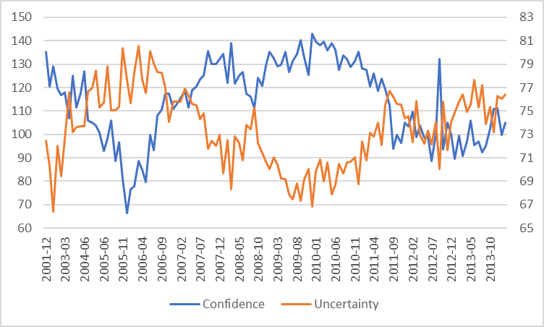

Figure 2 show the annual rate of growth of economic activity. There are two period of high economic growth (blue), where the rate of growth of IMACEC averaged 5%. Besides, there are two periods of decreases or increases in the growth rates (orange). The first is associated to the financial crisis of 2008-2009 and the earthquake of 2010. The second started in 2013, coinciding with the decrease in confidence and the increase in uncertainty. The last period of low economic growth (grey) is one of contracted economic activity, in which the annual rate of growth of IMACEC averaged 1.9%.

Figure 2. Economic Activity (IMACEC)
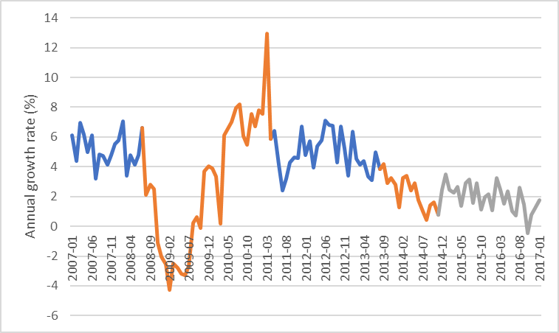

External factors

The external factors are the first two principal components of a set of foreign variables, similar to those used by Albagli and Luttini (2015): (1) Cooper price, (2) S&P500, (3) VIX, (4) Gross World Product (GWP), and (5) Federal Reserve interest rate. These variables were summarized in two principal components, to represent the dynamic of the business cycle of the world in a parsimonious way. The first principal component, pc1, is more correlated with GWP, Cooper price and FED interest rate, while the second principal component, pc2, is more correlated with S&P500 and VIX.

Figure 3. Principal Components: Global Business Cycle
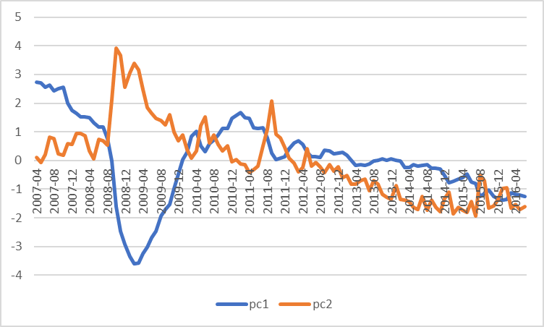

Sample

The studied period is april-2007 to june-2016, a time interval determined by the availability of data.

The analysis is focused in three periods of interest:
- 2008-2010: period of the US financial crisis, the fall in economic activity and the subsequent recovery.
- 2011-2013: a period of a high and stable economic growth (coinciding with the mining boom).
- 2014-2016: period of the decrease in economic activity, with a subsequent persistently low economic growth (period of contracted economic activity).

Analysis of economic growth

Historical decomposition of the business cycle

I estimate the individual contributions of each structural shock to the movements in the rate of growth of IMACEC (using natural logarithms to approximate the percentage growth rates), after the estimation of a VAR model including the internal and external variables described above as endogenous variables. The results of the VAR estimates are shown in table 1. Then, I obtained annual averages for each sequence of shocks, and I plot them in the date corresponding to the last of the 12 averaged shocks.

Table 1. VAR estimates
 | pc1 | pc2 | confid | uncert | imacec
c | 1.3912 | -4.0279 | 35.7275 | 59.8703*** | 0.1051
 | (1.2297) | (-1.6105) | (1.1855) | (4.0882) | (1.3990)
pc1(-1) | 1.4660*** | -0.0877 | 6.5974** | 0.2657 | 0.0018
 | (14.2850) | (-0.3865) | (2.4133) | (0.2000) | (0.2582)
pc2(-1) | -0.0245 | 0.9193*** | 2.9123** | 0.0677 | -0.0042
 | (-0.4445) | (7.5560) | (1.9866) | (0.0950) | (-1.1482)
confid(-1) | -0.0038 | 0.0055 | 0.5062*** | -0.0509 | -0.0003
 | (-0.7691) | (0.5000) | (3.8352) | (-0.7938) | (-0.7920)
uncert(-1) | -0.0192* | 0.0338 | -0.0054 | 0.1557 | -0.0010
 | (-1.8530) | (1.4781) | (-0.0196) | (1.1631) | (-1.4362)
imacec(-1) | -1.2625 | 6.1579* | 26.4273 | -6.4083 | 0.3063***
 | (-0.8649) | (1.9083) | (0.6796) | (-0.3391) | (3.1612)
pc1(-2) | -0.4907*** | 0.1234 | -6.4857** | -0.2388 | 0.0044
 | (-4.6423) | (0.5280) | (-2.3035) | (-0.1746) | (0.6298)
pc2(-2) | 0.0601 | -0.0123 | -2.5030* | 0.3648 | 0.0047
 | (1.0985) | (-0.1019) | (-1.7184) | (0.5154) | (1.3065)
confid(-2) | 0.0072 | -0.0035 | 0.2463** | -0.0951 | 0.0004
 | (1.5311) | (-0.3364) | (1.9764) | (-1.5703) | (1.1802)
uncert(-2) | -0.0022 | 0.0180 | -0.2339 | 0.1549 | -0.0004
 | (-0.2222) | (0.8294) | (-0.8960) | (1.2212) | (-0.5491)
imacec(-2) | -1.7559 | -2.2031 | -54.0262 | 9.0268 | 0.2369***
 | (-1.2729) | (-0.7224) | (-1.4702) | (0.5055) | (2.5874)
t-values in parenthesis. * p < 0,1, ** p < 0.05, *** p < 0.01

Figure 4 show that, during the first period, 2008-2010, the main shocks affecting economic activity were the external shocks (pc1 and pc2) and the confidence shocks. During the period 2011-2013, the confidence shocks were the most important, followed by the uncertainty shocks and one of the external shocks (pc2). Finally, in the period 2014-2016, the most important negative shocks were the confidence shocks and the external shocks pc2. Besides, it can be seen that the confidence shocks have been more important than the external shocks.

Figure 5 show the annual average of the sum of the external shocks (pc1 + pc2) and internal shocks (confidence + uncertainty + imacec). During the first period, 2008-2010, both types of shocks were very correlated. Then, between 2011 and 2013, in the first place the external shocks were the most important, but then the internal shocks became more important. Finally, between 2014 and 2016, the external shocks were most important at the beginning of the period, causing the fall in the growth rate of the economy, but then, since 2005, the internal shocks have been the most negative ones.

Figure 4. Structural shocks to growth rate of IMACEC
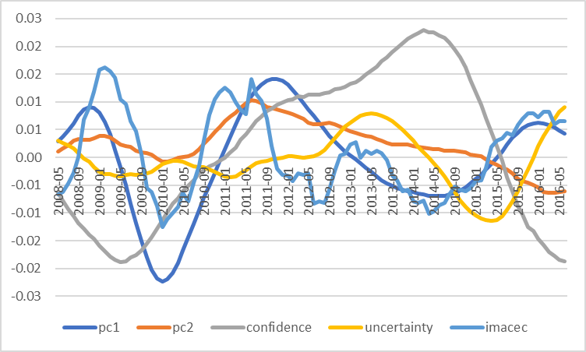

Figure 5. External and Internal shocks to growth rate of IMACEC
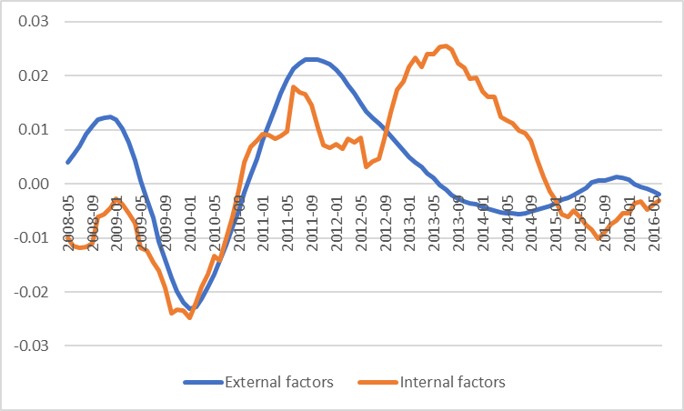

Rolling Windows estimations

The second methodological approach is based on Rolling Windows regressions, by using sub-samples of 36 months each one, allowing to perform 76 estimations. Each estimation used standardized data (within each sub-sample), to obtain comparable coefficients. The estimated coefficients of each sub-sample were stored and then, for each variable, the sum of the coefficients of each lag was plotted in the date corresponding to the last period of the corresponding sub-sample.

Figures 6 and 7 show that, during the period 2008-2010, the most important coefficients (with greater magnitude in absolute value) were those associated to the first external factor, pc1, as well as with the lags of the growth rate of IMACEC. In the second period, 2011-2013, initially the external factors were important, but then their importance decrease and increase (u-shaped). The effects of confidence and uncertainty are small at the beginning of the period, but at the end became important. Next, the external factor pc2 was the most important determinant between 2014 and 2015, while the effect of uncertainty and confidence became important in 2016.

Figure 6. Coefficients of the equation of the growth rate of IMACEC
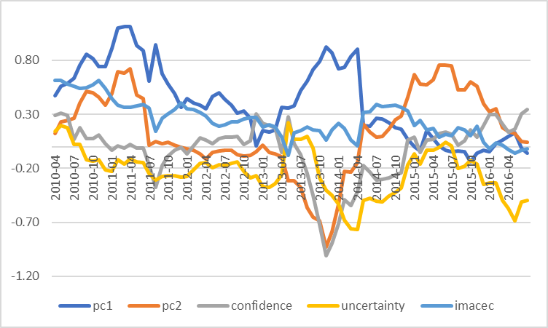

Figure 7. Coefficients of the equation of the growth rate of IMACEC (absolute value)
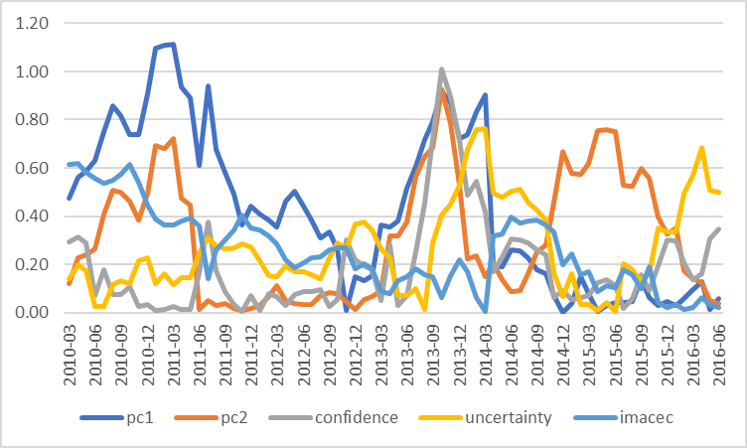

Figures 8 and 9 show the sum of the coefficients of internal and external variables. According to this analysis, in the period 2008-2010 the external factors had the most important effect on economic growth. During the period 2011-2013, the effect of both types of variables was reduced, but at the end of the period the effects increased. Finally, between 2014 and 2016, the external variables were the most important, at least until 2015, while in 2016 the internal variables became the most important.

Figure 8. Coefficients of internal and external factors of the equation of growth rate of IMACEC
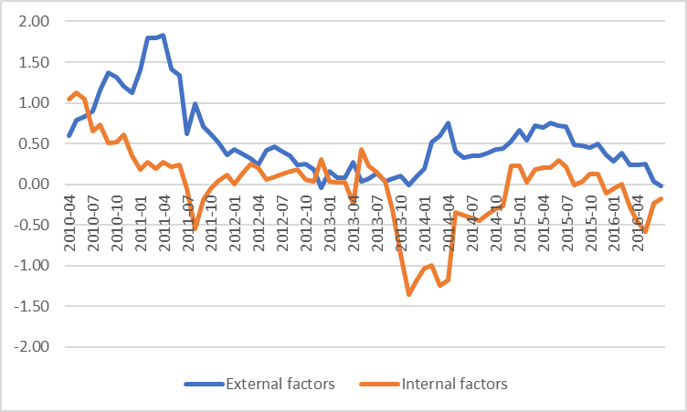

Figure 9. Coefficients of internal and external factors of the equation of growth rate of IMACEC (absolute value)
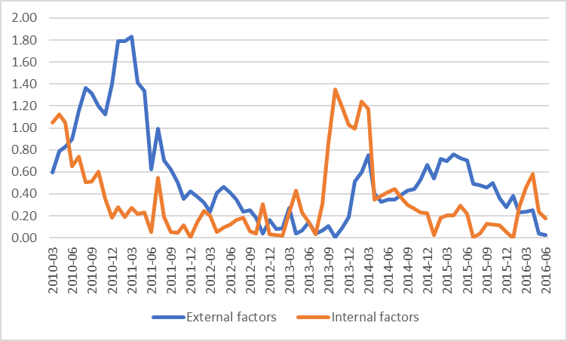

Analysis of confidence

In the previous section I studied the importance of the different factors that have affected the economic activity during the last years, analyzing the importance of two types of factors: external and internal factors. Among the internal factors are confidence and uncertainty (related to confidence), that could also be affected by external factors. In this section, I extend the analysis to study the importance of the internal and external factors affecting the confidence of economic agents during the period of interest. The model is the same presented in table 1, but focused in the results of the equation in which confidence is the dependent variable.

Historical decomposition of confidence

Figure 10 shows that, during the period 2008-2010, the main shocks affecting confidence were the own shocks and the external shocks pc1. During the period 2011-2013, the own shocks are the most important, as well as in the period 2014-2016.

Figure 11 shows that, during the period 2008-2010 internal and external were positively correlated, and then, during the next two periods, 2011-2013 and 2014-2016, the internal shocks were the most important to explain the dynamics of confidence.

Figure 10. Structural shocks to confidence
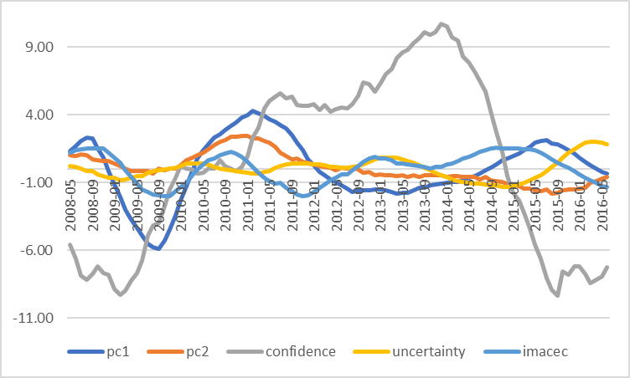

Figure 11. External and internal shocks to confidence
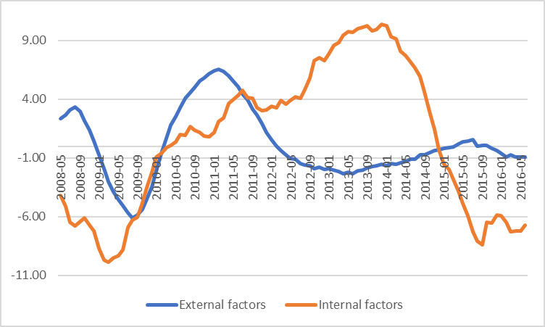

Rolling Windows estimations

Figures 12 and 13 show that during the periods 2008-2010 and 2011-2013, the most important coefficients (greater magnitude in absolute value) were those associated to confidence. Then, between 2014 and 2016, there was a temporary increase of the importance of the external factor pc2, followed by a subsequent increase, also temporal, of the importance of confidence.

Figure 12. Coefficients of the equation of confidence
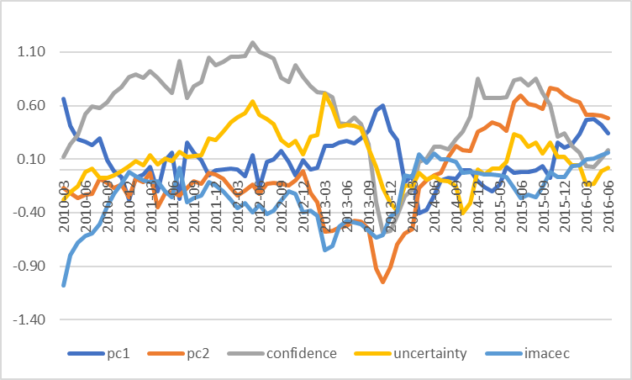

Figure 13. Coefficients of the equation of confidence (absolute value)
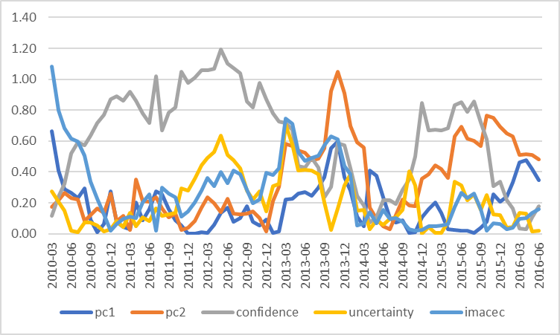

Figures 14 and 15 show the sum of the coefficients of internal and external variables. In general, it is observed that the internal factors were more important than the external factors to determine confidence in Chile during the period of analysis, excepting for some recent periods, like the end of 2013 and the beginning of 2014, and during the year 2016.

Figure 14. Coefficients of external and internal factors of the equation of confidence
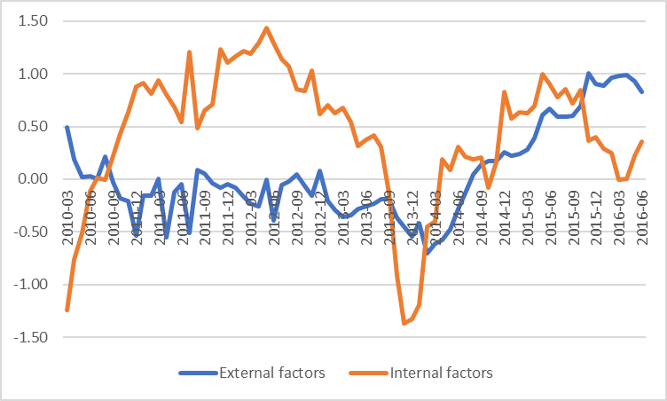

Figure 15. Coefficients of external and internal factors of the equation of confidence (absolute value)
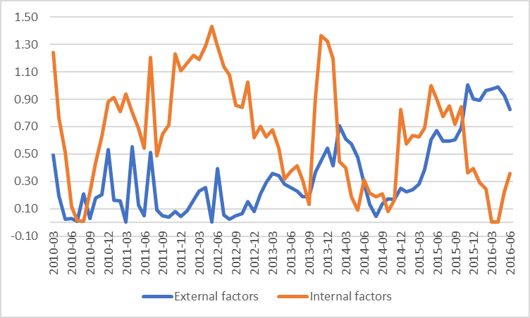

Conclusions

The objective of this work was to identify which factors are the most important to explain the contraction of economic activity observed during the last three years. To this end I used two methodological approaches that suggest the following explanation: (1) the fall in the growth rate of the economy is explained by external factors, probably related with the end of the mining boom, (2) the low growth rates observed since then are explained by a combination of internal and external factors, among which prevail the internal factors.

In addition, I studied the factors that have determined the confidence of the economic agents. The analysis suggest that the dynamics of confidence is mostly explained by internal factors, given that the external factors have been important only in short periods of time.

References

Elías Albagli y Emiliano Luttini (2015). Confianza, Incertidumbre e Inversión en Chile: Evidencia Macro y Micro de la Encuesta IMCE, Informe de Política Monetaria (IPOM) julio 2015.

Índice de Percepción del Consumidor: consumer confidence index published by the Center for Research in Business and Economics (Universidad del Desarrollo) http://negocios.udd.cl/ceen/
IMACEC (Índice mensual de actividad económica) is a monthly index of economic activity published by the Central Bank of Chile.
To allow a better identification of the plotted trends.

